# REPORT

**Objective/ Vision**

A library management software where admin can add/view/delete librarian and librarian can add/view books, issue, view issued books and return books.

**Users of the System**

1. Admin
2. Libraian

**Functional Requirements**

**1. Admin**

1. Can add/view/delete librarian
2. Can logout

**2. Librarian**

1. Can add/view books
2. Can issue books
3. View issued books
4. Return Books
5. Can logout

**Tools to be used**

1. Use any IDE to develop the project. It may be Eclipse /Myeclipse / Netbeans etc.
2. MySQL for the database.

**Front End and Back End**

1. **Front End:** Java Swing
2. **Back End:** MySQL

**How project works?**

Some screenshots are given below:

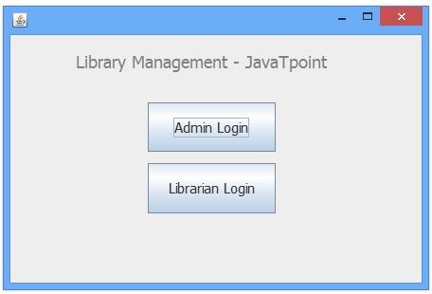



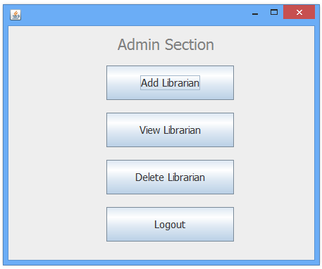

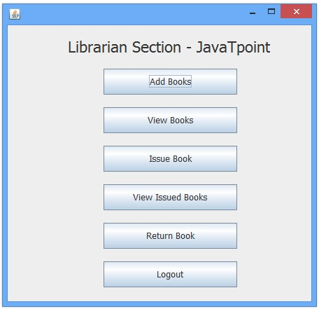

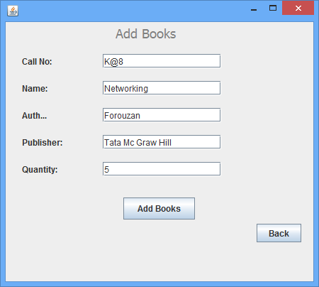

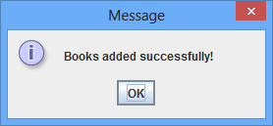

**Class Diagram**

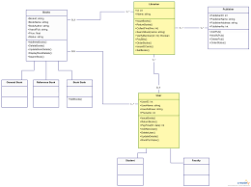

**Dataflow Diagram**

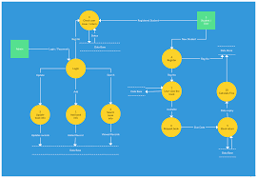

**Activity Diagram**

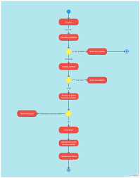

**ER Diagram**

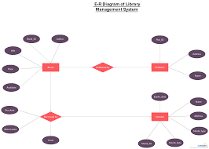

**Sequencial Diagram**

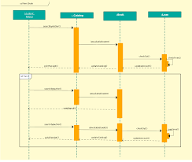

***Submitted by :sakshi kashyap***

***Enroll no. 1810DMTCYFS03237***

***Cs-i***